Bank Integration in D365 F&O

Bank Integration – D365 Finance & Operations (F&O) This document provides a sample end-to-end Bank Integration scenario in Microsoft Dynamics 365 Finance & Operations, covering outbound payments and inbound bank statements (MT940).

Bank Integration in D365 F&O – Types
In Microsoft Dynamics 365 Finance and Operations, bank integration can be mainly done in 2 types:
1. SFTP-Based Integration
- Files are transferred through a secure SFTP server
2. Folder-Based Integration
- Files are shared through a network folder

HDFC and ICIC bank intigration -SFTP

HDFC – SQL connection string
Server=20.235.32.157;Database=HDFCBankTransactions;User Id=sa;Password=Qov24806121212111
ICICI bank file path
/ICICI/Inbound

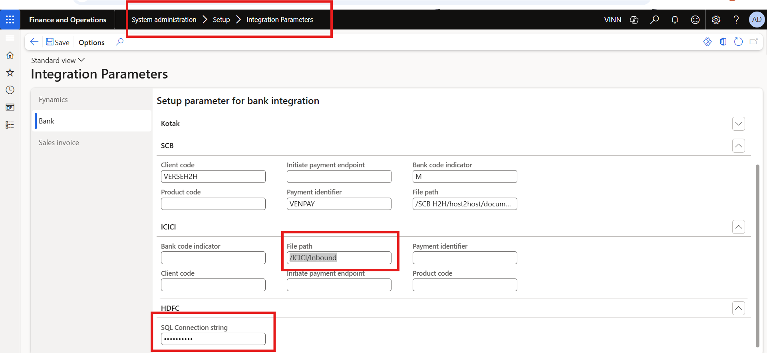

Users with role ‘Process intra bank payment maintain’ should be able to see the process vendor bank payment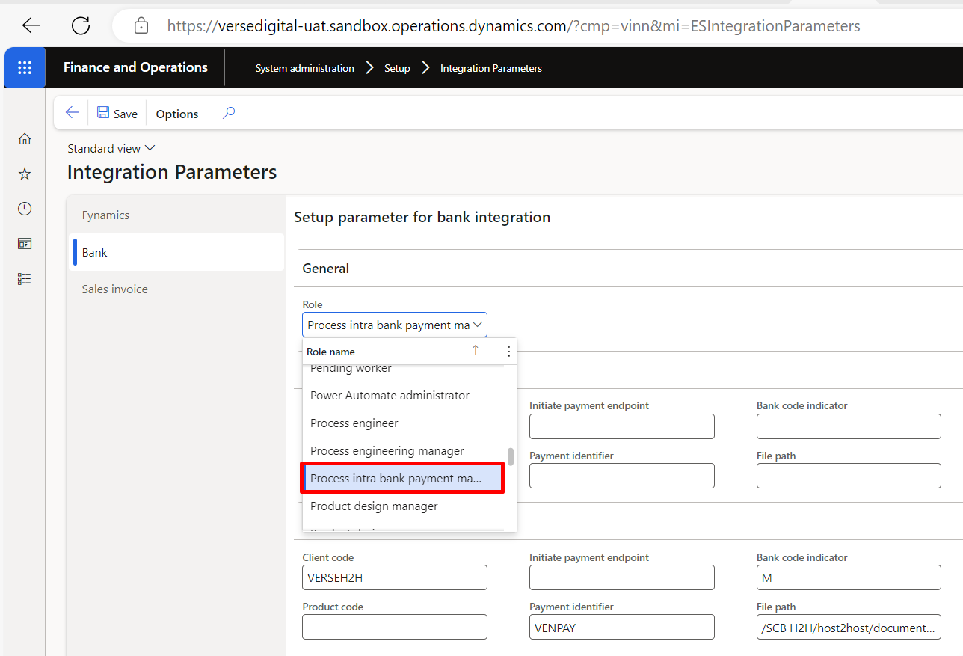and process intra bank payment buttons .

For bank account below parameter are mandatory and also bank group.
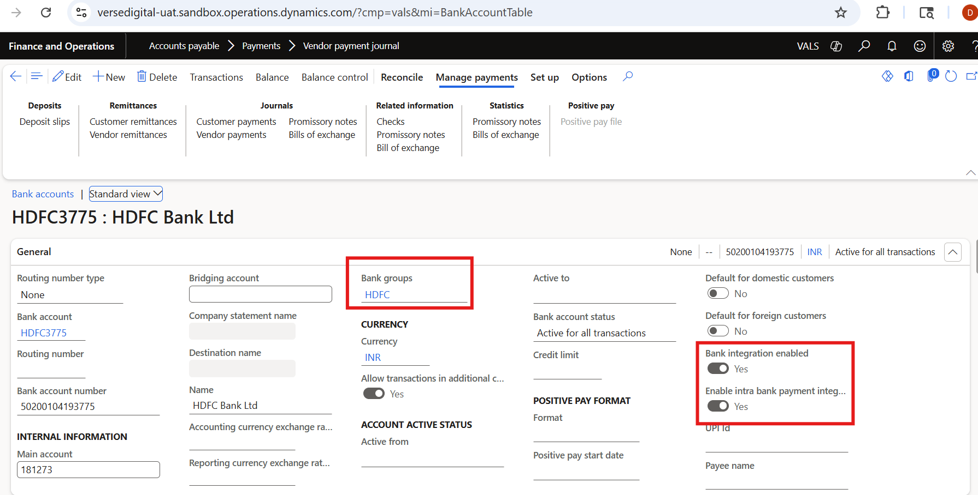

Outbound Payment Process
Vendor Invoice Posted
↓
Payment Proposal Created
↓
Payment Journal Generated
↓
Payment File Generated (ER)
↓
File Sent to Bank (SFTP)
↓
Bank Processes Payment

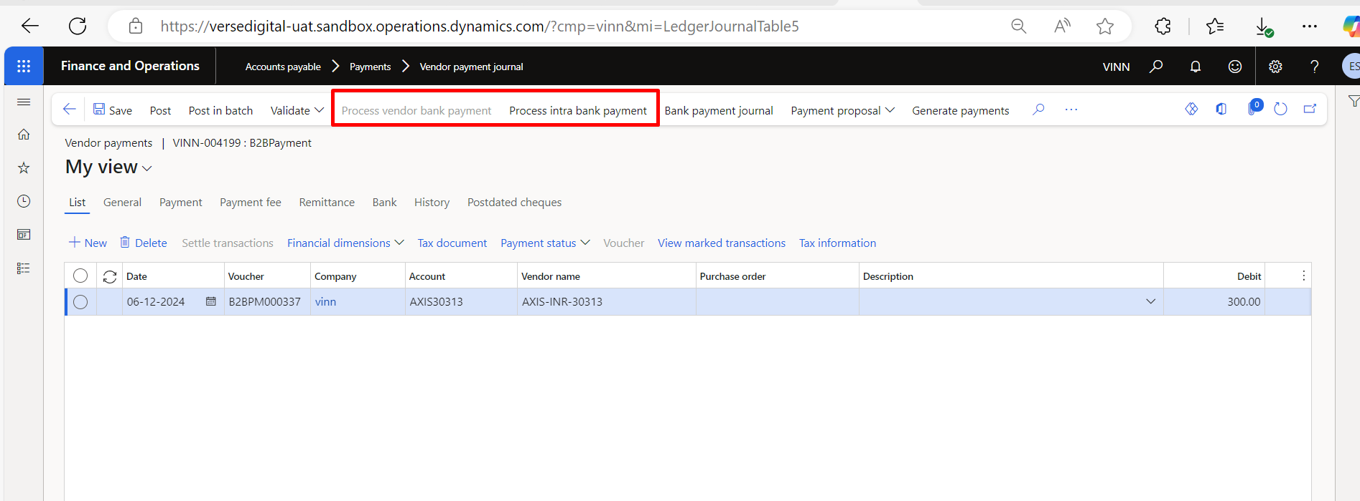
process vendor bank payment button should be enabled in the Vendor payment journal only when the Account is Vendor and the offset account is bank, the payment status is sent and the transaction workflow status is approved, if the workflow is enabled. 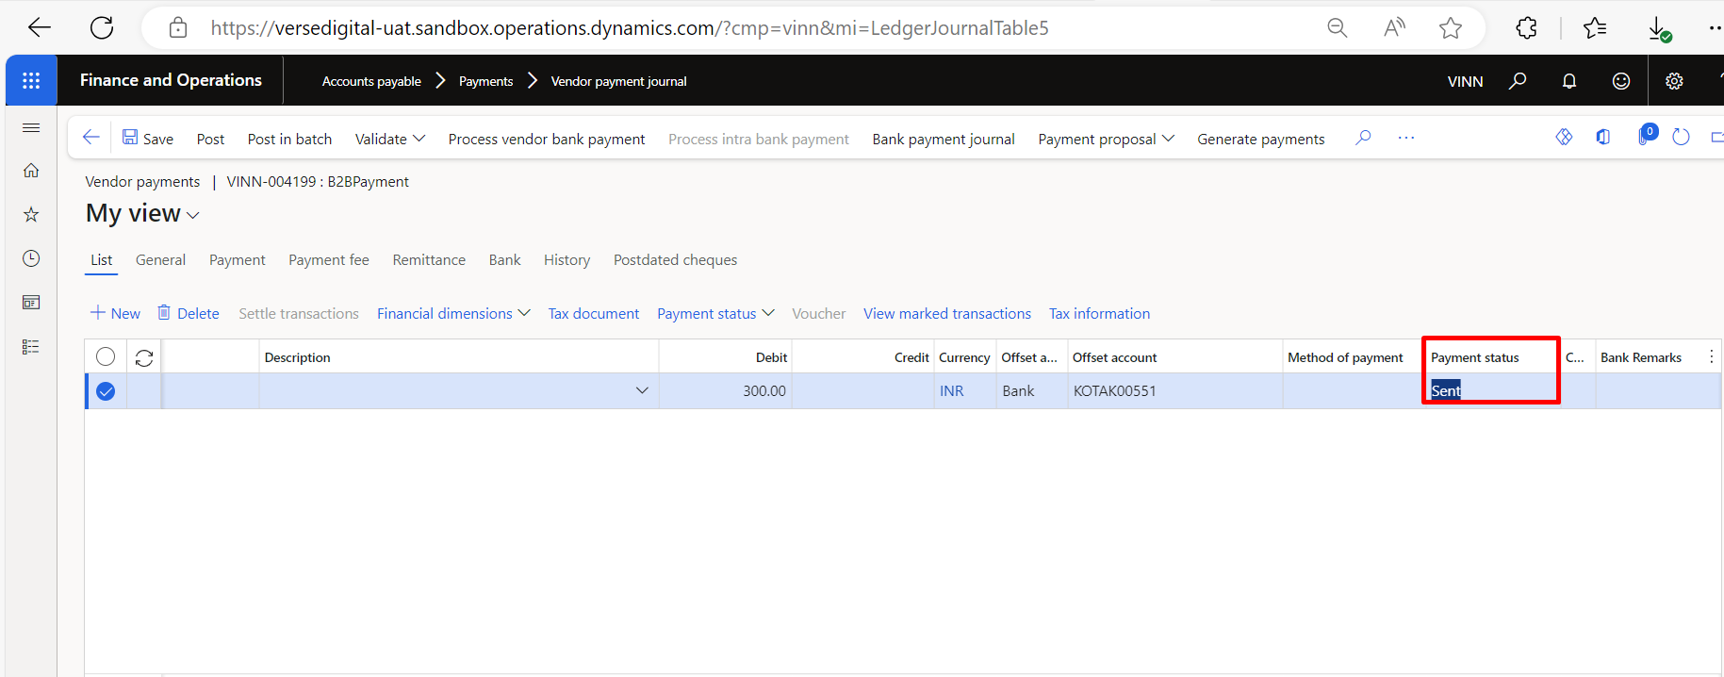

process intra bank payment button should be enabled in the Vendor payment journal only when the Account is Bank and the offset account is also bank, the payment status is sent and the transaction workflow status is approved, if the workflow is enabled. 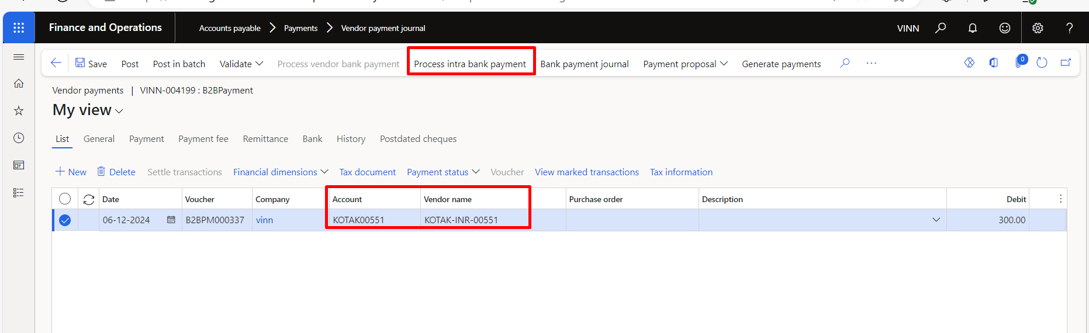

SFTP – Process HDFC
When payment is initiated b2b and also v2b file will be created in below folder with below sample details
C:\HDFCExports\PGPUtility\SOURCEPATH
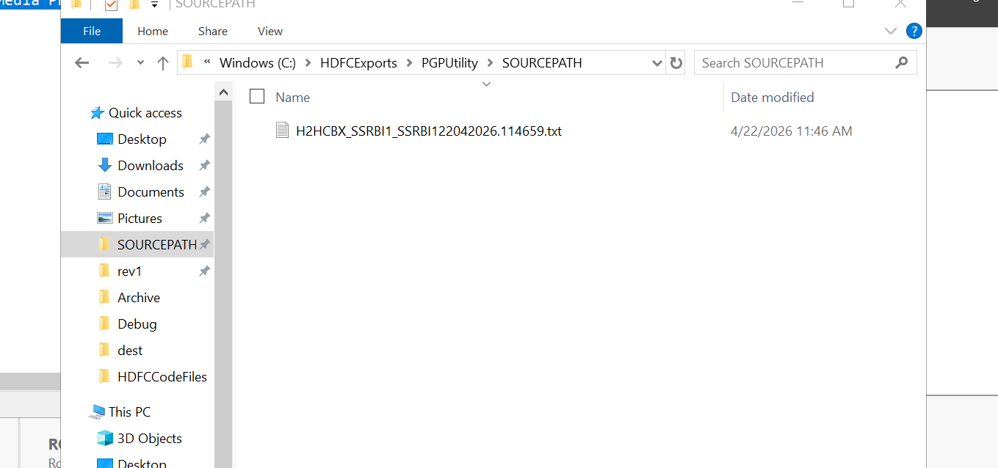
Sample transaction
N,,50200059492433,100.00,Affrise Media Private Limited,,,,,,,,,5639544111,,,,,,,,,22/04/2026,,HDFC0001098,Bank,,

Bank will pick the file and share the reverse file in below folder path and status will be update in F &O
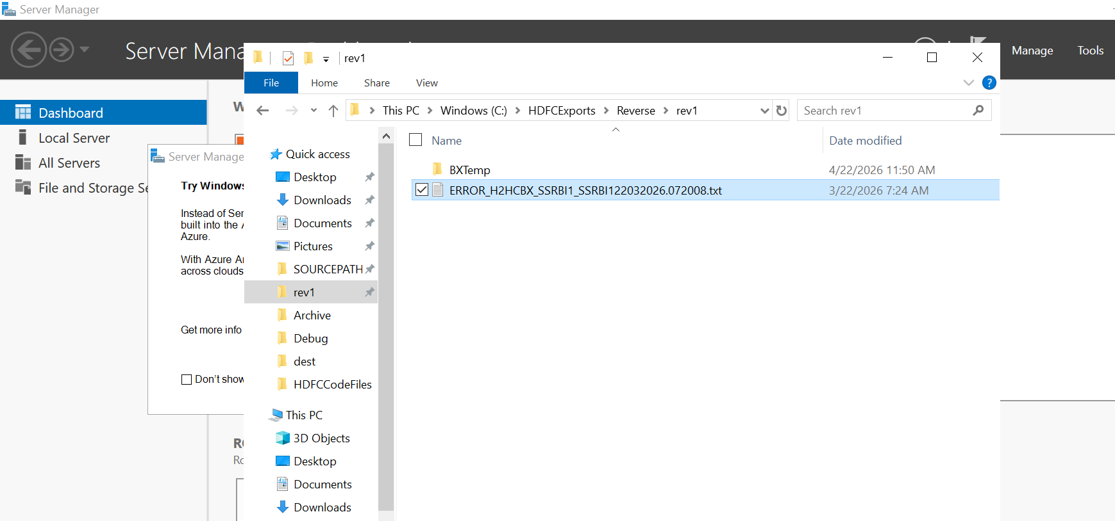

Inbound Bank Statement (MT940) Process Flow
.
Process Steps Bank Generates MT940
↓
File Placed on SFTP
↓
MT940 Imported into D365
↓
Bank Reconciliation Worksheet
↓
Automatic / Manual Matching
↓
Reconciliation Posted

